**Day-3 Assignment**

**Name: Subrat Shukla**

1. **Implementing Subtotals**
   1. **Calculating Subtotals Using GROUP BY with ROLLUP**

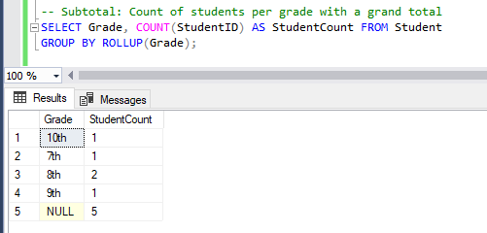

* 1. **Calculating Average Age with Subtotals Using GROUP BY and ROLLUP**

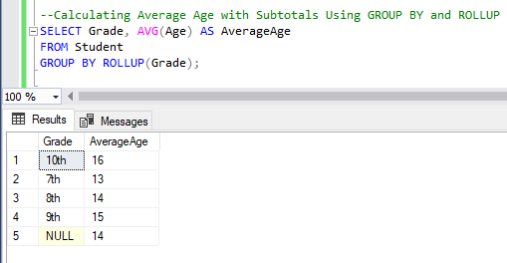

1. **Implementing Stored Procedures**
   1. **Creating a Stored Procedure for Adding New Students**

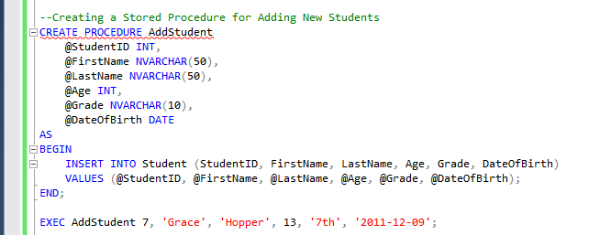

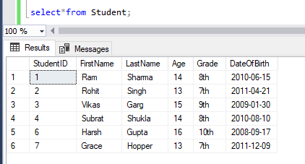

* 1. **Creating a Stored Procedure to Retrieve Students by Grade**

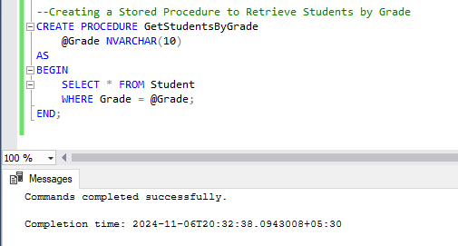

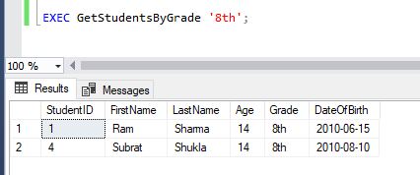

* 1. **Creating a Stored Procedure to Update Student Grades**

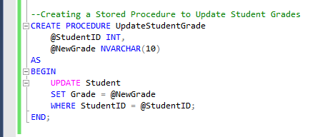

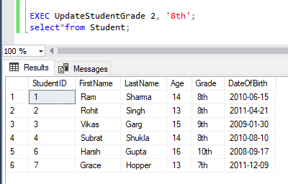

* 1. **Creating a Stored Procedure for Grouping and Total Aggregations**

